The Ring Counter
In the Shift Register, we saw that if we apply a serial data signal to the input of a serial-in to serial-out shift register, the same sequence of data will exit from the last flip-flip in the register chain after a preset number of clock cycles thereby acting as a sort of time delay circuit to the original signal.
But what if we were to connect the output of this shift register back to its input so that the output from the last flip-flop, Q_{D} becomes the input of the first flip-flop, D_{A}. We would then have a closed loop circuit that "recirculates" the DATA around a continuous loop for every state of its sequence, and this is the principal operation of a Ring Counter. Then by looping the output back to the input, we can convert a standard shift register into a ring counter. Consider the circuit below.

4-bit Ring Counter
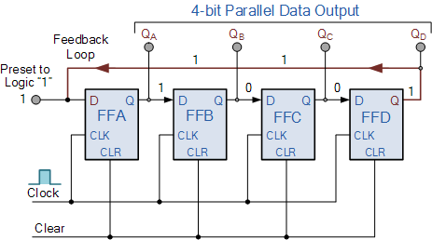
The synchronous Ring Counter example above, is preset so that exactly one data bit in the register is set to logic "1" with all the other bits reset to "0". To achieve this, a "CLEAR" signal is firstly applied to all the flip-flops together in order to "RESET" their outputs to a logic "0" level and then a "PRESET" pulse is applied to the input of the first flip-flop ( FFA ) before the clock pulses are applied. This then places a single logic "1" value into the circuit of the ring counter.
So on each successive clock pulse, the counter circulates the same data bit between the four flip-flops over and over again around the "ring" every fourth clock cycle. But in order to cycle the data correctly around the counter we must first "load" the counter with a suitable data pattern as all logic "0's" or all logic "1's" outputted at each clock cycle would make the ring counter invalid.
This type of data movement is called "rotation", and like the previous shift register, the effect of the movement of the data bit from left to right through a ring counter can be presented graphically as follows along with its timing diagram:

Rotational Movement of a Ring Counter
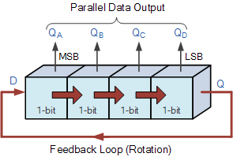
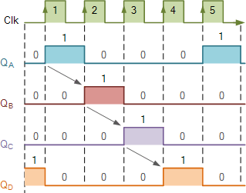
Since the ring counter example shown above has four distinct states, it is also known as a "modulo-4" or "mod-4" counter with each flip-flop output having a frequency value equal to one-fourth or a quarter (1/4) that of the main clock frequency.
The "MODULO" or "MODULUS" of a counter is the number of states the counter counts or sequences through before repeating itself and a ring counter can be made to output any modulo number. A "mod-n" ring counter will require "n" number of flip-flops connected together to circulate a single data bit providing "n" different output states.
For example, a mod-8 ring counter requires eight flip-flops and a mod-16 ring counter would require sixteen flip-flops. However, as in our example above, only four of the possible sixteen states are used, making ring counters very inefficient in terms of their output state usage.

Johnson Ring Counter
The Johnson Ring Counter or "Twisted Ring Counters", is another shift register with feedback exactly the same as the standard Ring Counter above, except that this time the inverted output Q of the last flip-flop is now connected back to the input D of the first flip-flop as shown below. The main advantage of this type of ring counter is that it only needs half the number of flip-flops compared to the standard ring counter then its modulo number is halved. So a "n-stage" Johnson counter will circulate a single data bit giving sequence of 2n different states and can therefore be considered as a "mod-2n counter".

4-bit Johnson Ring Counter
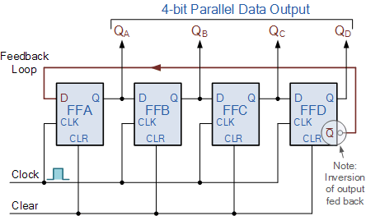
This inversion of Q before it is fed back to input D causes the counter to "count" in a different way. Instead of counting through a fixed set of patterns like the normal ring counter such as for a 4-bit counter, "0001"(1), "0010"(2), "0100"(4), "1000"(8) and repeat, the Johnson counter counts up and then down as the initial logic "1" passes through it to the right replacing the preceding logic "0".
A 4-bit Johnson ring counter passes blocks of four logic "0" and then four logic "1" thereby producing an 8-bit pattern. As the inverted output Q is connected to the input D this 8-bit pattern continually repeats. For example, "1000", "1100", "1110", "1111", "0111", "0011", "0001", "0000" and this is demonstrated in the following table below.

Truth Table for a 4-bit Johnson Ring Counter
Clock Pulse No | FFA | FFB | FFC | FFD
0 | 0 | 0 | 0 | 0
1 | 1 | 0 | 0 | 0
2 | 1 | 1 | 0 | 0
3 | 1 | 1 | 1 | 0
4 | 1 | 1 | 1 | 1
5 | 0 | 1 | 1 | 1
6 | 0 | 0 | 1 | 1
7 | 0 | 0 | 0 | 1
As well as counting or rotating data around a continuous loop, ring counters can also be used to detect or recognise various patterns or number values within a set of data. By connecting simple logic gates such as the AND or the OR gates to the outputs of the flip-flops the circuit can be made to detect a set number or value. Standard 2, 3 or 4-stage Johnson ring counters can also be used to divide the frequency of the clock signal by varying their feedback connections and divide-by-3 or divide-by-5 outputs are also available.
A 3-stage Johnson Ring Counter can also be used as a 3-phase, 120 degree phase shift square wave generator by connecting to the data outputs at A, B and NOT-B. The standard 5-stage Johnson counter such as the commonly available CD4017 is generally used as a synchronous decade counter/divider circuit. The smaller 2-stage circuit is also called a "Quadrature" (sine/cosine) Oscillator/Generator and is used to produce four individual outputs that are each "phase shifted" by 90 degrees with respect to each other, and this is shown below.

